**Consultation Report**

**Consultation Subject:**

The Ministry of the Interior extends an invitation to the esteemed public to contribute their perspectives on the current state and future trajectory of the Ministry of Interior's smart services.. Share your insights to enhance operational efficiency, ensure accurate and swift services, and make them universally user-friendly.

**The objective of consultation:**

In seeking public input, the Ministry of Interior strives to gather diverse opinions and proposals to improve its smart services for customers. The aim is to enhance efficiency, elevate the quality of life for the Emirati community, and align with the visionary leadership's commitment to positioning the UAE at the forefront of international competitiveness indicators.

**Expected decisions as a result of consultation:**

Introducing innovative smart services to foster collaboration with partners by leveraging technical connectivity and integrating procedures between local and federal government agencies.

**Open Date: July 01, 2024**

**Closed Date: July 31, 2024**

**Languages used: Arabic – English**

**Marketing: Social Media - Website - Smart Notifications - Email – Screens**

**Number of participants: 41**

**Number of comments: 41**

**Comments topics:**

|  |  |  |  |
| --- | --- | --- | --- |
| **Topic** | **Modern technology** | **Awareness-raising** | **Developing procedures** |
| **No. of comments** | 13 | 1 | 27 |

**Summary of Comments:**

* Increasing the use of modern technologies such as artificial intelligence to improve efficiency and security.
* Raising awareness on the proper usage of e-services.
* Enhancing the user experience through improved application design.

**Result:**

**First:** Several workshops were organized to develop innovative work processes aimed at updating and improving services, streamlining procedures, and increasing their speed. These workshops also reviewed and evaluated the improvements achieved so far in the Ministry's services. The goal is to simplify and reduce government procedures, thereby boosting government efficiency, quality, and flexibility in the UAE. These efforts are part of the Ministry’s ongoing commitment to enhancing customer experience and improving government services, ensuring that services are delivered in an easy, efficient, and timely manner without compromising productivity or quality.

**Second:** Focus sessions were conducted with customers as part of the "Design Your Service" initiative. These sessions aimed to gather customer opinions, suggestions, and feedback for further improvement of services. The workshops covered a range of services provided by the Ministry, with the intention of applying best practices, enhancing service access by reducing transactions and procedures, and addressing challenges and obstacles faced by clients during their service experience.

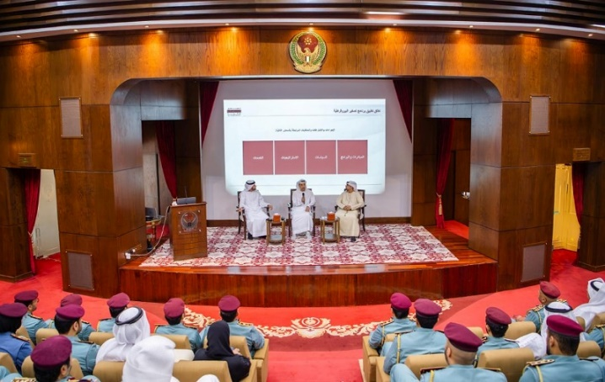**Appendices:**

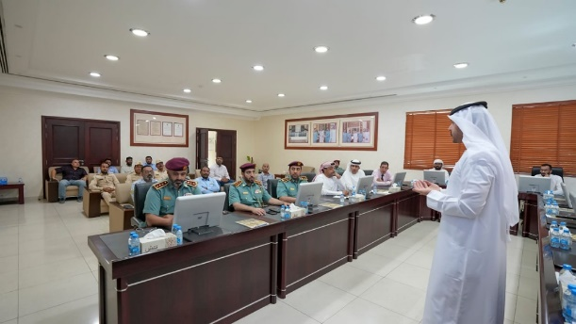

<https://www.instagram.com/reel/DByfJfZyl1I/?utm_source=ig_web_copy_link&igsh=MzRlODBiNWFlZA>==

<https://www.instagram.com/reel/C_xY69nySzt/?utm_source=ig_web_copy_link&igsh=MzRlODBiNWFlZA>==